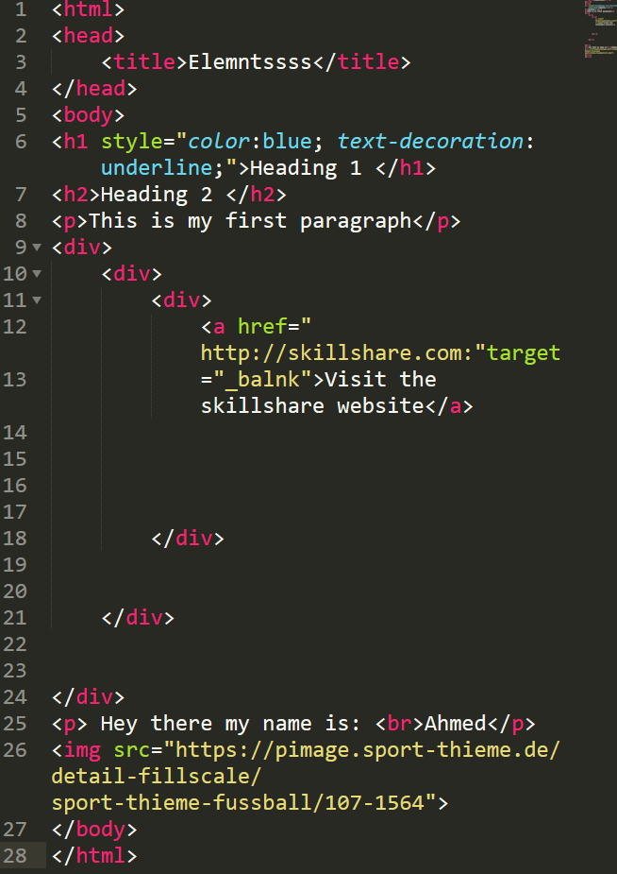 Summary or the first HTML project

Tags

h1 headline

P paragraphs

Div everything in the body

a links

img adding images

br line break – without closing tag

span is between elelment or separate

Attributes inside each tags

style --Color or text attributes

Css

Class .

# ID for only one element

Id is more wighted than class and class is more weighted than Tag attributes

WRITING NOTTES

<!--- ………………. --> ( In the Geman Keyboard ! – 1 bottom , * at the 8 botom

OR COMMENTS THAT BROWSER CANT SEE

/* …………………*/